# Soft skill assignment 1: Effective Communication

**Task: Write professional emails based on any 5 of the following scenarios. Ensure clarity, conciseness, and a formal tone.**

1.

**Thank you Email**

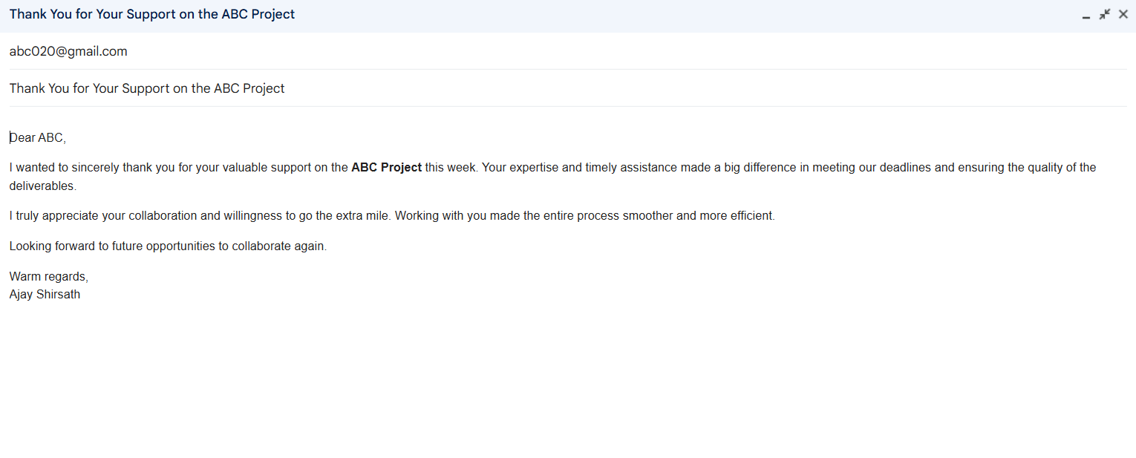

2.

**Letter of Apology**

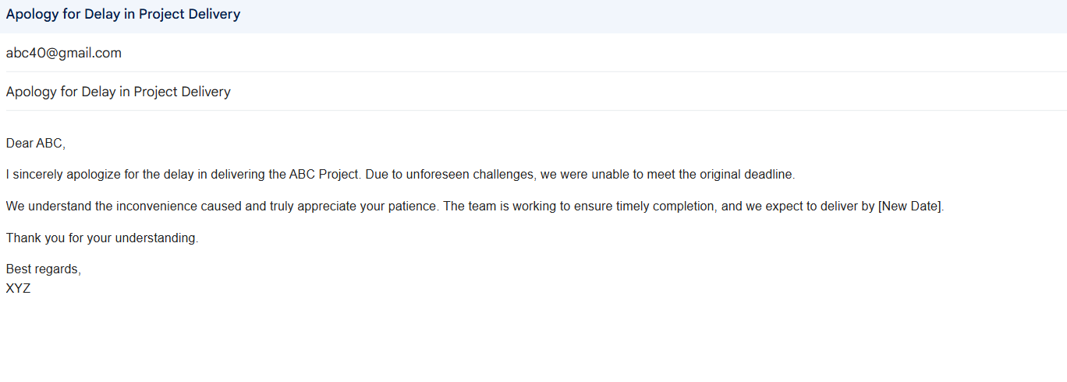

3.

**Email of Inquiry for Requesting Information**

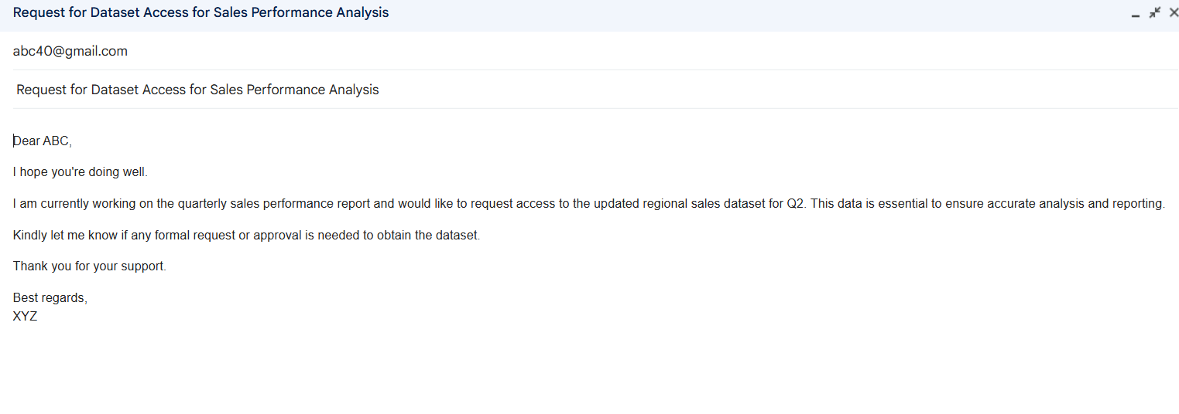

4.

**Asking for a Raise in Salary**

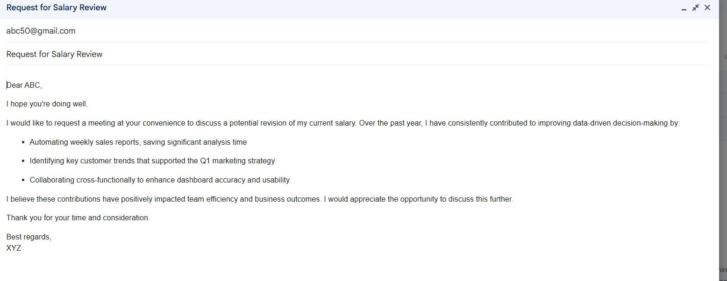

5.

**Resignation Email.**

